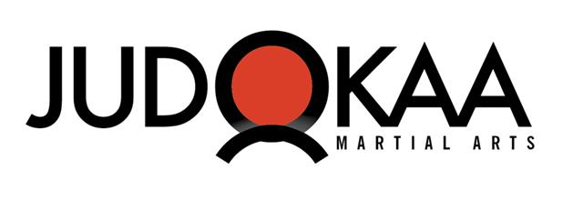Judokaa Martial Arts
Free Week of Classes
Please present this coupon to Judokaa Martial Arts located at 165 Garrard Road Whitby L1N 3K4 to gain entrance to the Judokaa Dojo and receive your free week of Martial Arts Training!

Student Name: ___________________________________________________________________

Signature:_________________________________________ Date:__________________________

Children’s Junior Beginner Judo & Kozen Monday to Thursday 6:00 pm – 7:00 pm
Children’s Advance Judo & Kozen Technical Monday to Thursday 7:00 pm - 8:00 pm
Adult Judo class Tuesdays to Thursday’s 8:00 pm - 9:30 pm
Adult Open Class Saturday’s 9:00 pm - 10:30 pm
Adult Open 18+ Class Sunday’s 15:00 pm - 16:30 pm
MMA Striking Program Mondays 8:00 pm – 9:30 pm

Sensei Kevin's Cell (905).626.0300 Address:
Email judokaamartialarts@gmail.com 165 Garrard Road. Whitby,
Fax 905.725.3310 Whitby, ON L1N 3K4

